24

.

**FULL SUBTRACTOR**

**EXP.NO: 24**

**AIM:**

To design and imple

ment the full

subtractor

using

Logisim

simulator.

**PROCEDURE:**

Pick and place the n

ecessary gates.

1)

2)

Insert 3 inputs into t

he canvas.

d OR gate.

3)

Connect the inputs t

o the XOR gate, AND gate an

4)

Insert 2 outputs into

the canvas.

s using the connecting wires.

5)

Make the connection

6)

Verify the truth table.

**TRUTH TABLE:**

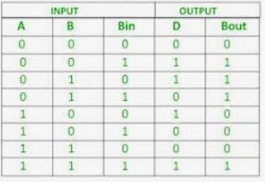

Diff=(A

⊕

B)

⊕

'

Borrowin

'

|  |  |  |
| --- | --- | --- |
| Borrow=A'.B + (A | ⊕ | B)' |

Logic Diagram:

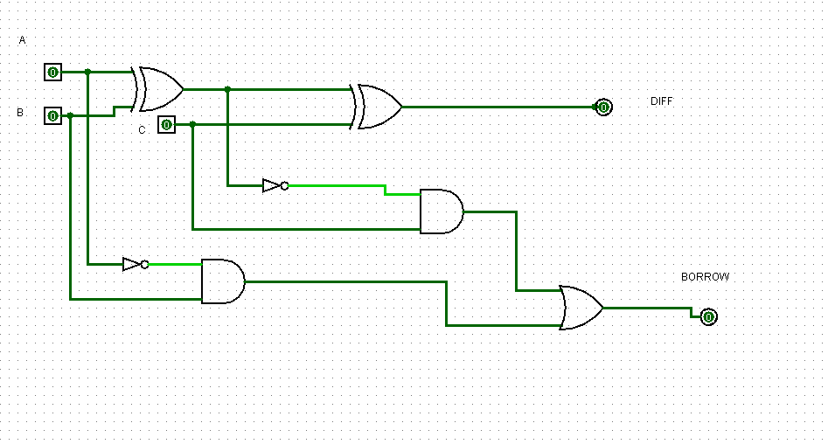

|  |  |  |
| --- | --- | --- |
| Full | Subtractor | using NAND Gates: |

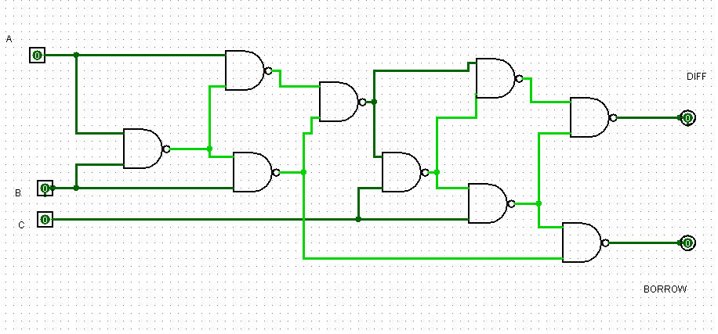

|  |  |  |  |  |
| --- | --- | --- | --- | --- |
| Full | Subtractor | using | NOR | Gates: |

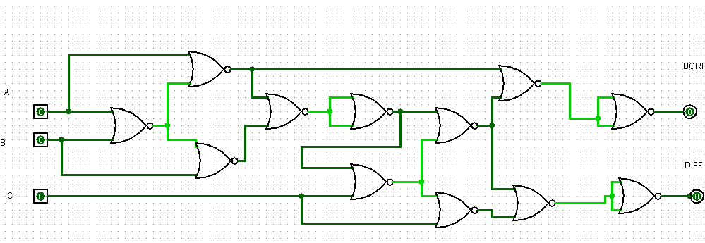

# OUTPUT

**RESULT:**

Thus full

subtractor

has been designed and implemented successfully using

logisim

simulator.